Project Development Phase
Model Performance Test

Date | 10 February 2025
Team ID | SWTID-2026-6064
Project Name | Streamlining IT Procurement: Automating Standard Laptop Orders with Flow Designer
Maximum Marks

Model Performance Testing:
Project team shall fill the following information in model performance testing template.
S.No. | Parameter | Screenshot / Values
 | Data Rendered | 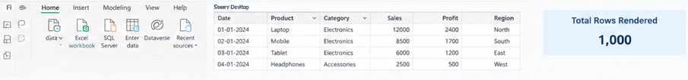
 | Data Preprocessing | 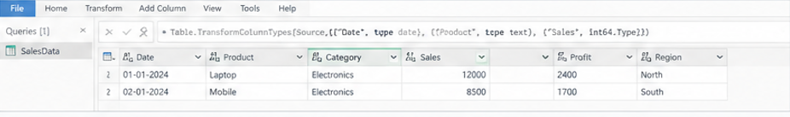
3. | Utilization of Data Filters | 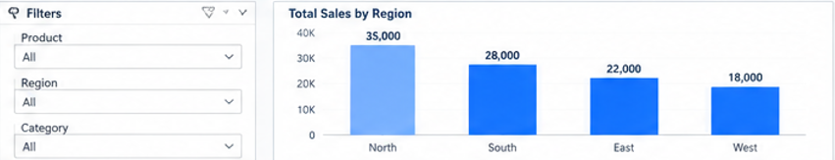
4. | DAX Queries Used | 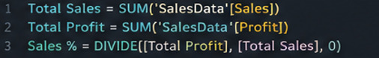
5. | Dashboard design | 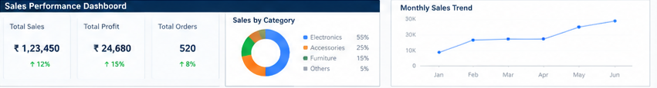
6 | Report Design | 